

Lab assignment no: 1
Tayyaba Hussain
SP24-BSE-059
Information security (lab)
BS software engineering

Question 1: Write python code for your designed stream cipher approach for encryption decryption.
Code:
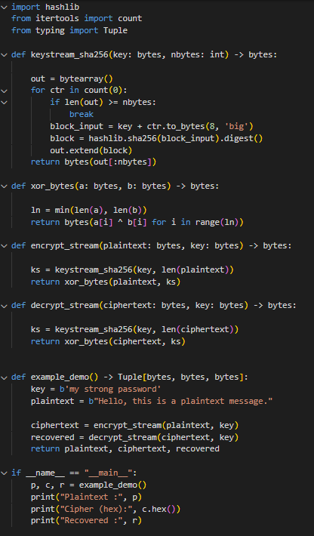

Output:

Explanation:
Working Principle:
The cipher follows the One-Time Pad (Vernam cipher) principle where:
$$C=P⊕K_{s}\text{and}P=C⊕K_{s}$$
Here, $P$is plaintext, $C$is ciphertext, and $K_{s}$is the keystream.
As the same operation (XOR) is used for both encryption and decryption, the process is symmetric and reversible.

Code summary:
keystream_sha256(key, nbytes)
This function generates a pseudorandom keystream of the required length.
- It repeatedly computes SHA-256 of the concatenation of the secret key and a counter (key || counter).
- Each SHA-256 hash gives a 32-byte block, and blocks are joined until the total length matches the message size.
- This simulates the keystream generation in modern stream ciphers like Salsa20.
xor_bytes(a, b)
This function performs a byte-wise XOR operation between two byte sequences.
- XOR is used because in stream ciphers, encryption and decryption both depend on XOR between the plaintext and keystream.
- The XOR operation ensures that applying the same keystream again recovers the original plaintext.
encrypt_stream(plaintext, key)
- Generates a keystream equal in length to the plaintext.
- Performs XOR of the plaintext with the keystream to produce ciphertext.
- Returns the ciphertext in bytes.
decrypt_stream(ciphertext, key)
- Uses the same process as encryption.
- Because XOR is reversible, decrypting restores the original plaintext.

Question 2: Design and implement an adversarial attack approach for your proposed stream cipher approach.

Code:
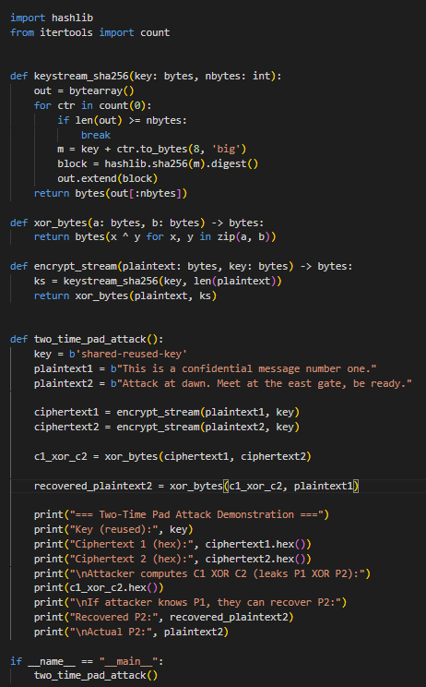

Output:
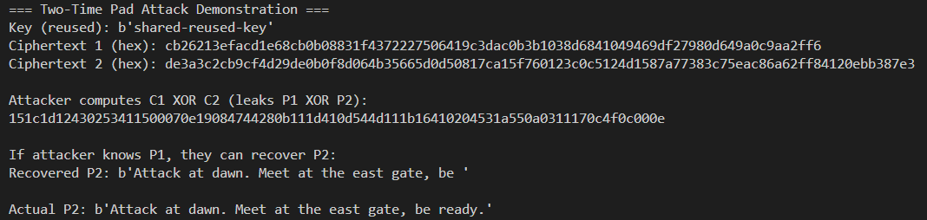

Code explanation:
Same keystream reused intentionally:
Two different plaintext messages are encrypted with the same key (hence same keystream). This breaks the basic rule of stream ciphers.
Attacker’s perspective:
An eavesdropper who intercepts both ciphertexts can compute:
$$C_{1}⊕C_{2}=(P_{1}⊕K_{s})⊕(P_{2}⊕K_{s})=P_{1}⊕P_{2}$$
This eliminates the keystream and directly reveals the XOR of the two plaintexts.
Plaintext recovery:
If the attacker knows or can guess one plaintext (for example, part of a known header or common message), they can recover the corresponding part of the second plaintext:
$$P_{2}=(C_{1}⊕C_{2})⊕P_{1}$$
Program demonstration:
- The program encrypts two messages using the same key.
- It calculates C1 XOR C2 to simulate what the attacker would compute.
- Then, assuming the attacker knows P1, it successfully recovers P2.

